TURKEY: HOSPITAL PPP PROGRAMME

ESTABLISHMENT OF A VALUE FOR MONEY METHODOLOGY FOR THE MINISTRY OF HEALTH

TERMS OF REFERENCE

1. INTRODUCTION

International Experience of Hospital PPPs
The rising demand and increased costs for health service delivery are straining health delivery systems worldwide. In most countries, the majority of the health delivery system is government controlled, with public hospitals accounting for the largest percentage of overall health care spending. At the same time public hospitals are perhaps the most complex and difficult environments in which to enact reform. Increasingly governments are considering various models of private sector participation within public hospitals – often referred to as Public-Private Partnerships (“PPP”). Such arrangements increasingly offer a viable approach to controlling costs, improving service, and even increasing access.
One such model is for the design, construction, financing and non-clinical operation of hospital and health facilities initiated by the UK in the mid 1990’s under the Private Finance Initiative (“PFI”). These types of PPPs are also referred as Hospital Infrastructure PPPs or Hospital PFIs. Today, there are more than 110 healthcare facilities that have been built in the UK using the Infrastructure PPP approach with total investment amount exceeding £ 11.6bn. This model of PPP has since spread to many countries with projects various stages of development or completion including: Canada (78 projects, investment amount totaling nearly EUR15bn); France (16 projects, investment amount totaling over EUR2bn); Spain (14 projects, investment amount totaling over EUR2bn); Australia (12 projects, investment amount totaling over EUR5bn); and South Africa (30 projects , investment amount totaling over EUR3bn). Other countries such as Italy, Portugal, Sweden, Germany, Egypt, Chile and Mexico have also carried out such projects on a more limited basis.
A study by the National Audit Organisation (“NAO”) of the UK on “The Performance and Management of Hospital PFI contracts” (17 June 2010) suggests that most contracts are performing satisfactorily, or better, and meeting the expectations of public sector management entities, known as Hospital Trusts in the UK. A key finding by the NAO of this report is that the Trusts had not dedicated sufficient resources to contract management. As with most new procurement methods, PFI contracts present a challenging task for the public authorities to manage. Most Trusts are managing their contracts well on a day-to-day business but need support with certain complex issues. This is especially important when the Hospital Trusts are trying to protect value for money of the PPP approach in their interactions with contractors regarding contractual disputes, managing the change process, fulfillment of obligations to ensure intended risk transferred are achieved as envisaged, and the expected level of performance is delivered. The importance of monitoring contracts effectively is also clear.

PPP it is only one of a range of public procurement models. In some cases, where UK PFIs have performed below expectations, often the evidence suggests that it was not the right procurement model to use. Hence, a strong business case, which should include a robust value for money (“VfM”) analysis, should be conducted well in advance.

The clear lessons learned from international experience, and most particularly the UK experience with hospital PPPs is that aspects related to a) project preparation, centrally VfM assessment; and b) performance and contract management. These TORs focus on the need for VfM assessment.

Turkey Hospital PPP Programme – Background and Basic Structure of PPP Contracts
Turkey’s hospital infrastructure sector, organised by the Ministry of Health (“MoH”), is in need of modernising its existing hospital infrastructure to bring it up to international standards, coupled with the expected need for more than 90,000 new hospital beds over the next ten years to 2023, according to MoH’s analysis. Provision of hospital beds is low currently, at 2.6 beds per 1,000 people in 2011, compared with an OECD-wide figure of 3.6. Under a strategy approved by the Turkish government, a key metric for hospital design standards is the average square meter per bed. The hospital space per bed, currently just 55 m² on average, is targeted to be set at approximately 175 m² per bed in line with international benchmarks. While large public investments are planned using traditional public sector approaches (approximately EUR 11 billion is being budgeted over this period), the Turkish government has also commenced an ambitious programme to deliver 30 new hospitals using a PPP approach. These new hospitals organised as so-called ‘integrated campuses’ range in size from 558 beds to 3,660. Total beds under this programme are 33,000 beds of which 26,000 are the replacement and modernizing of existing beds, while bringing on an additional 7,000 beds for long-term care patients (not hospital in-patient beds). The corresponding hospital infrastructure will be constructed, managed and maintained by private concessionaires under facilities management PPPs, while clinical services will remain the responsibility of MoH. As of September 2013, 16 of these hospitals have been awarded under international tender, while the remaining 14 are in various stages of feasibility study preparation or early tendering. The average capex value of each PPP contract tendered to date is EUR 435 million, such that the total capex value of the entire programme (30 individual hospital projects) is estimated to be approximately EUR 10 billion.
In Turkey, public hospitals operate poorly due to a lack of essential facilities. The government seeks to address this issue by rolling out a large scale hospital PPP programme (the “Programme”). The Programme has resulted in the launch of more than 16 tenders for the construction and provision of products and services for integrated hospital infrastructure projects under the Design-Build-Finance-Lease-Transfer (“DBFLT”) model. Under this model, the private sector is being called up to provide key infrastructure (buildings and equipment) and facilities management (excluding clinical services) pursuant to concession agreements with MoH. The provision of clinical services will continue to be provided by MoH under its own responsibility.
The winning PPP contractor will not take medical revenue and services risks because it will not be providing medical treatment or clinical services, nor will it be responsible for any patient interface, including, for example patient billing/collections. Instead, the Contractor will be compensated by MoH based on (1) availability of infrastructure facilities; and (2) provision and maintenance of certain support equipment (for example laboratory, imaging, sterilisation and disinfection) and support services (notably rehabilitation, linen and laundry, catering, waste management, building and land services, extraordinary maintenance and repair). All clinical operations will be carried out by MoH. This structure is in line with international best practice for hospital infrastructure PPPs and has been well established in the UK for over two decades with over 80 projects in operation as well as Canada, Spain, Italy.
The Contractor’s revenues will be based on availability (lease) payments (“APs”) and service payments (“SPs”) from MoH. Performance penalties will apply in case of underperformance. For those services subject to volume risk the Company will benefit from a minimum volume guarantee of 70 per cent, but some services will be subject to a market testing procedure every 5 years. The amounts of the payments due from MoH will be budgeted in the state budget.

The payment for services being provided by the Company will be divided into two main categories:

- Services which are not proportional to the occupancy rate of the hospital, consumption and/or level of utilisation (“Non-Volume Services”);
- Services that are impacted by the occupancy rate of the hospital and/or consumption (“Volume Services”).

For the construction of the facilities the Company will enter into a lump sum engineering procurement & construction (“EPC”) contract with a construction joint venture established by the Sponsors on an arms-length basis. Under the EPC contract the Company will pass down all design and construction related risks and responsibilities under the PPP Agreement to the EPC contractor.

For the operation, maintenance and provision of the services defined above, the Contractor will enter into an Operation and Maintenance (“O&M”) agreement with an O&M joint venture established by the Sponsors. For the provision of the services various experienced service providers will be subcontracted. The O&M joint venture will sign a long term contract with an experienced service integrator which will support it to manage the various service providers. Under this scheme the Contractor will pass down all the risks related to the provision of the services and the operation and maintenance of the facilities. The main shareholder in the PPP’s SPV will guarantee the obligations of the O&M joint venture on a joint and several basis.

Basic description of VfM and its importance

For the purposes of these TORs, VfM of project proposed as a PPP is broadly achieved when a project, compared to the PSC (i.e., the risk-adjusted cost of the proposed project if delivered by traditional public procurement means), provides more benefits from a ‘whole of government perspective’. This conceptual approach to VfM methodology follows OECD guidance (‘Recommendations of the Council on Public Governance Principles for PPPs, OECD, 2012). In essence, the calculation of an initial project cost estimate (capex), an assessment of the affordability of a given proposed PPP projects should be weighed against other projects within the government’s infrastructure investment programme. This is important in normal economic times, but made even more pressing in times of severely constrained public budgets. Essentially, a PPP (or a set of PPP presented as a programme) will need to be judged to fit within a budgetary envelope.

Beyond basic capex and opex costs, VfM analysis hinges upon the determination of the relative value one places on the ‘risk transfer’ from the public sector to the private sector of various aspects related to the project’s construction and O&M. For example, the ability to complete a project on time by the private PPP contractor has a value to public sector grantor and to society as a whole, but the monetary value of this can vary based on many assumptions. Another common example is that of technology change risk, with one assuming that the private PPP concessionaire will be able to adapt to changes over time more readily than the public sector agency. Here as well, major assumptions on the value of this risk transfer are implied. One major task of the consultant of these TORs is to develop a robust set of plausible assumption on the value of these transfers of risk.

2 OBJECTIVES

2.1 General purpose

This document establishes the Terms of Reference for consultancy work aimed at the development of a VfM methodology.

Elaborating and Adopting a VfM Methodology: Dentitions and Scope of Application

The Objective of the Support – The primary purpose of these TORs is to provide the MoH with a robust and defensible VfM methodology applied to the several of the Ministry’s pipeline of hospital PPP projects.

VfM analysis is defined as a method for comparing the range of available procurement and project implementation options to determine which project delivery option maximises benefits for end-users with regard to quantity, quality, and cost, expected over the whole of the project’s lifetime. VfM is important since prior to embarking on a PPP tender the public sector has other procurement options available to it, the most typical being the traditional public procurement approach. This public procurement option is the PSC. Therefore, a VfM methodology seeks to demonstrate in a rigorous manner that a given PPP project provides value versus a traditional public procurement approach. This can be critical not only in determining which projects to pursue as PPPs, but also in building a robust defence of the PPP choice as Turkey rolls out its hospital PPP programme. The application of the VfM approach will be carried out for all projects to be financed by the Bank, as well as all projects still under technical preparation by MoH.

3 SCOPE OF WORK

3.1 General

The consultant is tasked with first developing the VfM methdology for the Turkish case and then applying this to the following proejcts likely to be financed by EBRD (amongst other financial institutions) and all MoH PPP projects not yet awarded, as follows:

- Ankara Etlik Hospital PPP – bed capacity 3,566 with capex of approximately EUR 1,000 million
- Gaziantep Hospital PPP – bed capacity 1,867 with capex of approximately EUR 600 million
- Yozgat Hospital PPP – bed capacity 475 with capex of approximately EUR 118 million
- Adana Hospital PPP – bed capacity 1,539 with capex of approximately EUR 550 million
- Elazig Hospital PPP – bed capacity 1,038 with capex of approximately EUR 213 million
- Isparta Hospital PPP – bed capacity 755 with capex of approximately EUR 220 million

The EBRD will, subject to negotiations with the winning bidders, debt finance some portion of the above projects.

The following hospitals are in the tender phase currently:

1. Eskişehir City Hospital
2. İstanbul Bakırköy Integrated Health Campus
3. İstanbul Üsküdar Public Hospital

The following hospitals are in the pipleine phase:

- Antalya Health Campu
- Denizli City Health Campus
- Diyarbakır Kayapınar Health Campus
- Diyarbakır Yenişehir Health Campus
- İzmir Güney Health Campus
- İzmir Torbalı Health Campus
- Samsun Health Campus
- Şanlıurfa Health Campus
- Tekirdag Integrated Health Campus
- Trabzon Maternity Health Campus

All of the above shall be assessed on a VfM basis.

The Consultant is expected to prepare 5 VfM calculations and train the relevant MoH staff and subsequently provide ad-hoc support to the MoH on an additional 10 VfM calculations based on the training staff received. The 5 initial calculations can be previously tendered projects or future projects.

Task 1

The consultant shall:

- Review of VfM methodologies in hospital PPPs (e.g., UK, Australia, Canada, Spain, and Portugal).
- Take stock of experience and lessons learned from each of the relevant VfM assessment methodologies internally and apply these to the Turkey case, in order to develop a consensus-based best practice methodology.

Task 2

The consultant shall:

- Assessment of inputs categories in VfM analysis of the existing pipeline of projects
- This should include at a minimum: Capex, opex, finance, value of time, technology, management, all risks expressed in monetary terms

Task 3

The consultant shall:

- Assess Hospital PPPs within the context of overall Government priorities and funding commitments
- This should include some level of consultation with stakeholders with the MoH and other relevant ministries.

Task 4

The consultant shall elaborate the draft VfM methodology.

This should include such elements such as:
  - The project forms part of a major capital investment programme, requiring effective management of risks associated
  - construction and delivery risk;
  - the structure of the service and its appropriateness, allowing the public sector to define its needs;
  - service outputs that can be adequately contracted for in a way that ensures effective, equitable, and accountable delivery of public services into the long-term, and where risk allocation between public and private sectors can be clearly made and enforced;
  - the nature of the assets and services identified, as well as the associated risks, are capable of being costed on a whole-of-life, long-term basis;
  - the value of the project is sufficiently large to ensure that procurement costs are not disproportionate;
  - the technology and other aspects of the sector are stable, and not susceptible to fast pace change;
  - planning horizons are long-term with confidence that the assets and services provided are intended to be used over long periods into the future; and
  - the private sector has the expertise to deliver, there is good reason to think it will offer VfM and robust performance incentives can be put in place;

Other factors that should be considered within the VfM methodology include whether to what degree the projects provides for:

- The optimum allocation of risks between the various parties –requires that risks
are allocated to the party, or parties, which are best placed to manage and minimise these risks over the relevant period;
- A focus on the whole life costs of the asset rather than only the upfront costs
Involved;
- Integrated planning and design of the facilities-related services through an early
assessment of whether the possible integration of asset and non-asset services (e.g. soft services) should deliver VfM benefits;
- The use of an outputs specification approach to describe the Authority’s
requirements which, amongst other things, allows potential bidders to develop innovative approaches to satisfying the service needs of the procuring authorities;
- A rigorously executed transfer of risks to the parties which are responsible for them,
ensuring that the allocation of risks can be enforced and that the costs associated with
these risk are actually borne by the parties in the manner originally allocated and agreed;
- Sufficient flexibility to ensure that any changes to the original specification or
requirements of the procuring authority and the effects of changing technology or delivery methods, can be accommodated during the life of the project at reasonable cost to ensure overall VfM;
- Sufficient incentives within the procurement structure and the project
contracts to ensure that assets and services are developed and delivered in a timely,
efficient and effective manner, including both rewards and deductions as may be
appropriate;
- The term of the contract to be determined with reference to the period over which the procuring authority can reasonably predict the requirement of the services being procured. This will require careful considerations of factors including: potential changes in end-use requirements; policy changes; design life of the asset; the number of major asset upgrades or refurbishments during the period of the contract; potential
changes in the way services could be delivered (e.g. technical advancements); and the
arrangements for the asset at expiry of the contract;
- sufficient skills and expertise in both the public and private sectors to be determined and secured, and these are utilised effectively during the procurement process and subsequent delivery of the project; and
- Managing the scale and complexity of the procurement to ensure that procurement
costs are not disproportionate to the underlying project(s).

The above considerations and factors should be included in the Methodology in both quantitative and qualitative levels. The quantitative analysis should be developed suing an Excel-based model, with a ‘dashboard’ so that the MoH (and other Turkish ministries, in the even the event that this methodology is adapted more widely across other sectors using the PPP approach) users can readily use and apply it.

Task 5

Following the completion of the draft Methodology, a presentation to the MoH shall be made, for the purpose of refinement and feedback. The EBRD will also provide a review and commentary on the frat Methodology. The consultant should incorporate all comments to the extent possible, keeping with common practice for VfM analysis.

Task 6

Upon successful refinement of the draft Methodology, the consultant will prepare a final VfM methodology. It is vitally important that the MoH begin to develop a sense of ‘ownership’ of the Methodology.

This should be achieved by means of a thorough training process of key staff at the MoH on how the Methodology has been constructed, how is various aspects function within the quantitative and qualitative assignment of value/risk for any given project, and how the VfM excel-based model work s in detail. The training model shall last a minimum of two full weeks for key staff to be involved in the VfM assessment process within the Ministry. This effort is to be designed to facilitate the Methodology’s official adoption by Ministry of Health.

Task 7

The consultant shall prepare, jointly with the trained staff at the MoH, the VfM assessment for all projects mentioned in Section XX of these TORs. These calculations of VfM should be discussed and presented individually to the relevant project teams within the MoH and to the head of the PPP programme as a means of verifying the sets of inputs and assumptions made for each project. These VfM assessments for the projects being actively prepared with possible EBRD financing shall be shared also with EBRD.

4. IMPLEMENTATION ARRANGEMENTS AND DELIVERABLES

Working Arrangements and Logistics

The Consultant will work on a day-to-day basis with the MoH officials in charge, to keep it informed on the study development, difficulties encountered and take guidance.

The Consultant should acquire the necessary computer equipment, the cost of which will not be reimbursed. The cost of hiring an English/Turkish interpreter/translator will also be borne by the Consultant.

Deliverables

The Consultant will provide five (5) printed copies of the following reports in Turkish language and three (3) copies in English language:

Two weeks after the commencement of the study, an Inception Report providing a review of available data and documents, a plan for the assignment (schedule of tasks and schedule of the experts, showing periods spent in Turkey and periods spent at the Consultant headquarters). This report shall include the description of data availability and a proposed list of data that are needed to complete the work (to be agreed with the client).

Two months from the start of the Study, the draft VfM Methodology, to be presented alongside the review of the international experience to date in VfM assessments in order to underpin the design choices made for the Turkish case.

Three months from the start of the Study, the final VfM Methodology. Following approval by the Ministry, the consultant proceeds with the actual VfM assessment for each of the projects included in these TORs.

Four months from the start of the Study, a presentation of the VfM assessments for the following projects: Ankara Etlik Hospital PPP; Gaziantep Hospital PPP; Yozgat Hospital PPP; Adana Hospital PPP; Elazig Hospital PPP; and Isparta Hospital PPP. The MoH should validate and accept these Assessments. The MoH staff should participate actively in these Assessments.

Five months from the start of the Study, a presentation of the VfM assessments for the following projects: Eskişehir City Hospital; İstanbul Bakırköy Integrated Health Campus; İstanbul Üsküdar Public Hospita; Antalya Health Camus; Denizli City Health Campus; Diyarbakır Kayapınar Health Campus; Diyarbakır Yenişehir Health Campus; İzmir Güney Health Campus; İzmir Torbalı Health Campus; Samsun Health Campus; Şanlıurfa Health Campus; Tekirdag Integrated Health Campus; Trabzon Maternity Health Campus. The MoH staff should participate actively in these Assessments. The MoH should validate and accept these Assessments.

Two weeks after receiving observations on the Draft Final Report, delivery of the Final Report. This should contain the final version of the methodology and all Assessments, as well as a summary of the training module completed.

The total duration of the Study should not exceed 6 months in total.

All deliverables will be submitted printed to the head of the PPP Programme in the MoH, as well as to the EBRD, accompanied by the original files under MS Word and Excel spread sheets, including the assessment model.

Donor Visibility

Given the assignment is funded through the EBRD’s donor funded technical cooperation programme, the Consultant will be required to support the client to ensure visibility of these resources. Support on these visibility aspects can be obtained from the Bank’s Communications Department. Measures could include but not be limited to:

- All documents produced by the Consultant should mention donor support and bear the logo of the donor, when appropriate.
- Donor support to the project should be acknowledged in any public communication (press releases, launch of facilities)
- Local representatives of donors should be invited to any public event organised to promote the project (press conferences, inaugurations, possibly stakeholder participation programmes)

Please contact Lucia Sconosciuto (email: SconoscL@ebrd.com; tel: +44 20 7338 8155) for further information. Some donor visibility guidelines can also be provided by the Bank to Consultants at the start of an assignment.

5 CONSULTANT PROFILE

The Consultant Team will include:

- Team Leader, expert in VfM assessment
- Hospital PPP Experts

At least 50% of the total of staff-month time of should be spent in Turkey.

The Consultant shall be responsible for translating any document provided in Turkish language for the purpose of this study.

ANNEX 1: Typical SERVICE CLASSIFICATIONS for the anticipated Hospital PPP projects under the Programme

The services that the Company will have to provide are divided in 2 categories:

- Services which are not proportional to the occupancy rate of the hospital, consumption and/or level of utilisation (the “Non-Volume Services”).
- Services that are impacted by the occupancy rate of the hospital and/or consumption. Those services are further categorised into:
  - Medical Support services (the “Volume Clinical Support Services”) and
  - Volume Support Services (the “Volume Support Services”).

The services are also classified as “P1 Services” which are the obligatory services to be provided by the Project Co and “P2 Services” which are optional. Broadly, P1 Services are referred to as Hard Facilities Management Services, which revolve around maintenance of the infrastructure assets. P2 Services are referred to as Soft Facilities Management Services, which revolve around the support services of the hospital.

The MoH underwrites/guarantees minimum service payments for Volume Services equivalent to 70 per cent occupancy rate during the Operating Period.

The diagram below illustrates the different services.

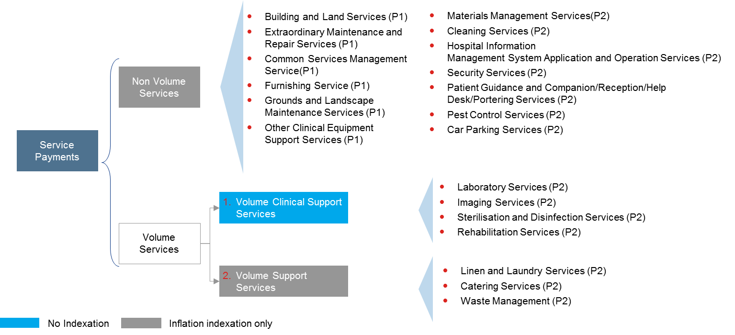

ANNEX 2: Key REVENUE DRIVERS for a typical PPP project in the Hospital Programme

The diagram below illustrates the key cash-flows and the Company’s sources of revenue which consist of quarterly AP and monthly SPs made by MoH and additional revenues generated from commercial activities.

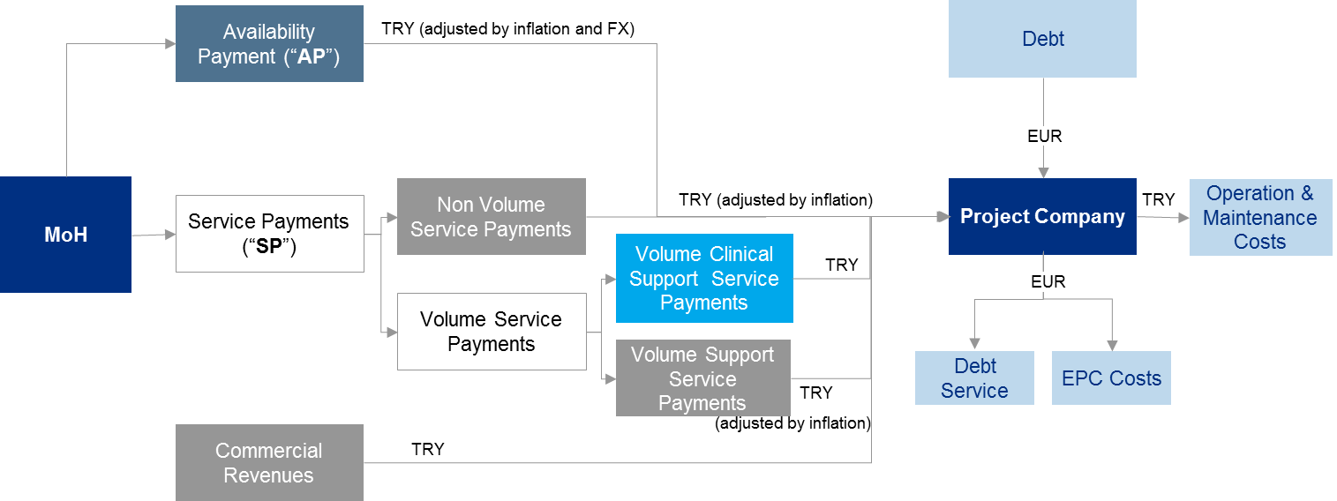

ANNEX 3: Typical O&M STRATEGY

The Sponsors will establish an O&M joint venture for the coordination and provision of the Services included in the PPP Agreement and its Schedules. In addition experienced sub-contractors will be contracted to provide those Services.

The following diagram shows the foreseen O&M structure:

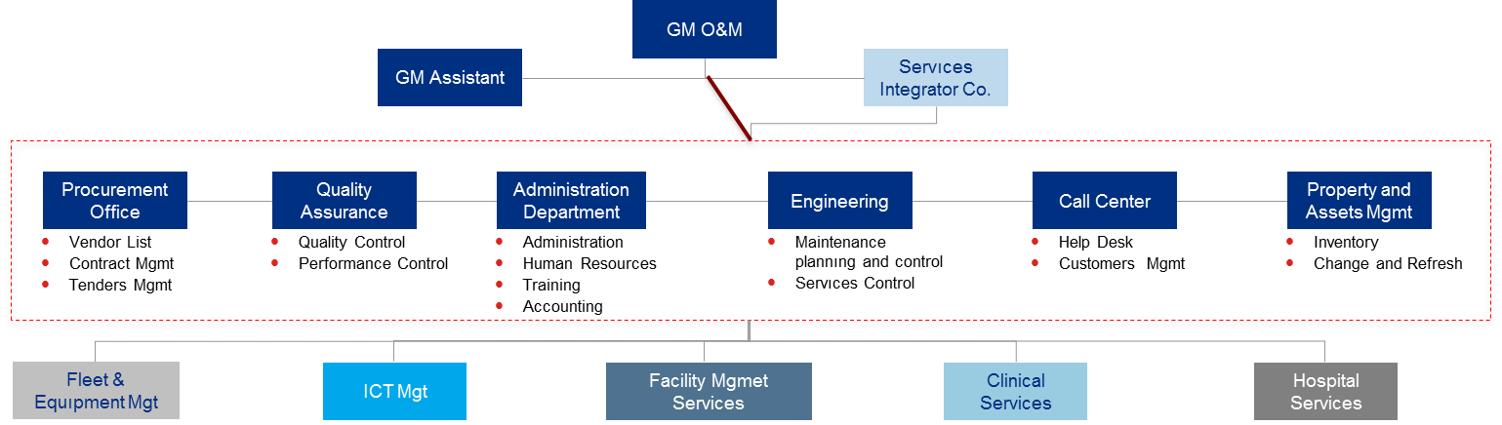

- Experienced consultants have been involved since the beginning of the process in order to advise on the critical aspects of the Project and to ensure they are in line with MoH requirements.
- The Company, pursuant to various agreements with the service providers, will pass down all operation and maintenance related responsibilities of the Company under the PPP Agreement to the O&M joint venture.
- The O&M joint venture, through a service integrator company (the “Service Integrator”) will contract various subcontractors to provide all the Services.
- The O&M joint venture will sign a long term contract (7-10 years) with the Service Integrator, which will support the O&M joint venture to manage the various service providers. The Service Integrator will perform the following roles:
  - Service Design and Purchase: it includes, inter alia, analysis of needs and performance specification definitions.
  - Management role: the Service Integrator will coordinate and monitor the service providers.
  - Control on system design, check-list and service providers.
- The contracts will be drafted in line with lenders typical requirements.

These factors are taken from the UK’s VfM Assessment Guidance document, November, 2006, HM Treasury.

